Tool Guide – DNSRecon

Introduction
DNSRecon is a DNS enumeration and reconnaissance tool written in Python. DNSRecon helps attackers/pen testers in gathering information from DNS by using DNS queries. It can help locate subdomains, map out the attack surface of a domain and gather intelligence for further scanning or exploitation.
Safety Disclaimer: Use only on networks and systems for which you have explicit authorisation. Unauthorized use of tools can be Illegal, unethical and harmful.

Setup and Launch
  - Step1: Open Deakin Detonator Toolkit
- Open Terminal in Linux
- Navigate to your Deakin Detonator Toolkit directory: (cd ~/Deakin-Detonator-Toolkit)
- Run DDT by using the following command line: (yarn run tauri dev)
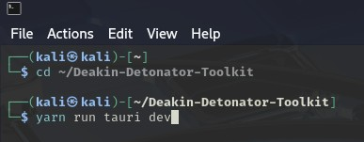
  - Step2: Find Tool-example
- Click on Tools to the left (or use the quick search bar)
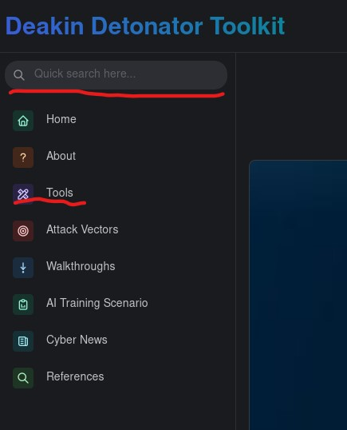
- If you clicked on Tools, scroll down and find DNSRecon and click go

Configuration and Usage
  - Step3: Configuring DNSRecon
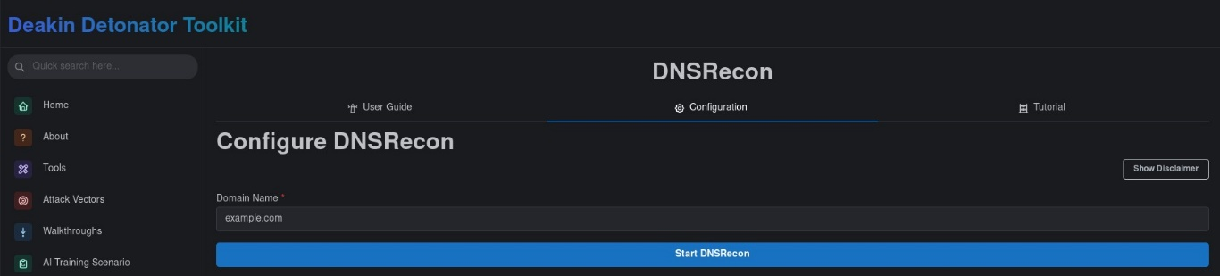
- Enter the domain you wish to use DNSRecon on, e.g. “example.com”
  - Step4: Results
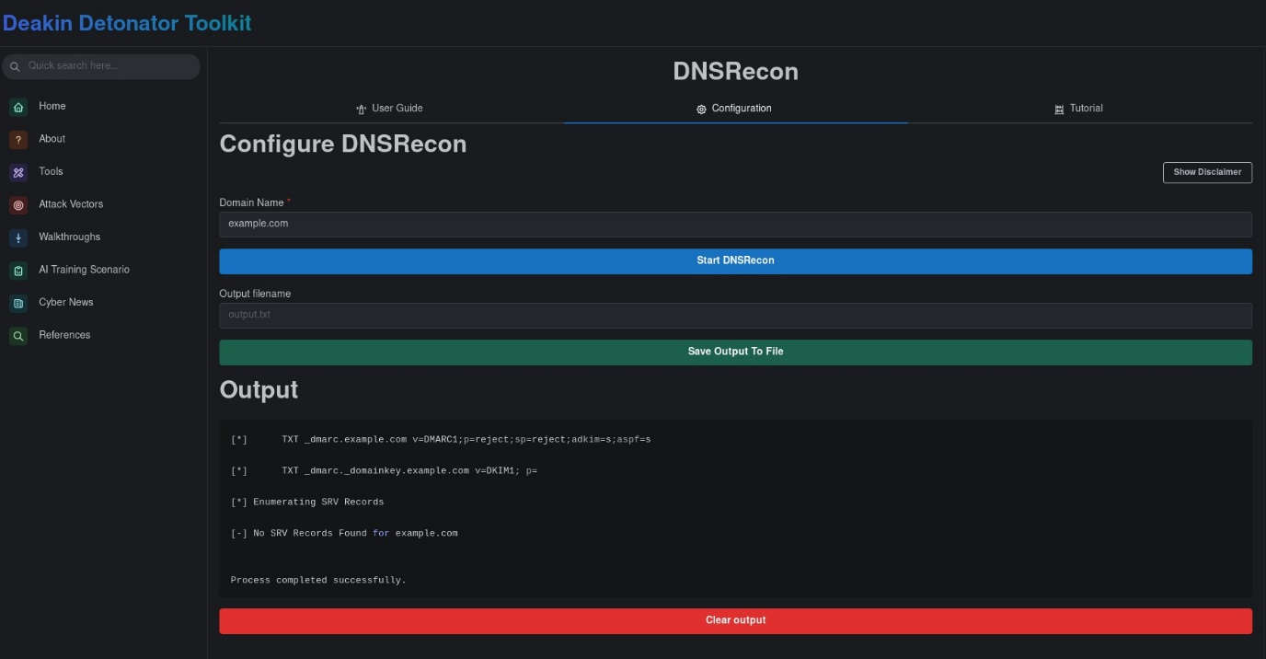
- You will be given an output that should end with “process completed successfully” and be sure to scroll up in the Output field to see the rest.
- Optional: You can save your output by filling out the new “Output filename” field with an appropriate name (output.txt) and then clicking “Save Output To File” button
- Optional: You can copy your output to your clipboard by clicking the little clipboard in the top-right of the output area.

Output Explanation
Note: your output will naturally be dependent on what domain you used, the following is non-comprehensive example output of what you could get from using DNSRecon on domain “example.com”.
- Dnsrecon -d example.com
  - The command to run dnsrecon
- DNSSEC is configured for example.com
  - DNSSEC is enabled for the domain, which helps protect from tampering.
- DNSKEYs
  - Cryptographic public keys used.
- SOA ns.icann.org ###.#.###.##
  - SOA (start of Authority) records, which contains admin info about the domain
- NS a.iana-servers.net ###.##.###.##
  - NS (Name Servers), DNS servers that are authoritative for the domain.
- A and AAAA records
  - A maps the domain to an IPv4 address
  - AAAA maps the domain to an IPv6 address
- TXT records
  - Free-form text records.

